**Sequence Diagram:**

**1. Current Account**

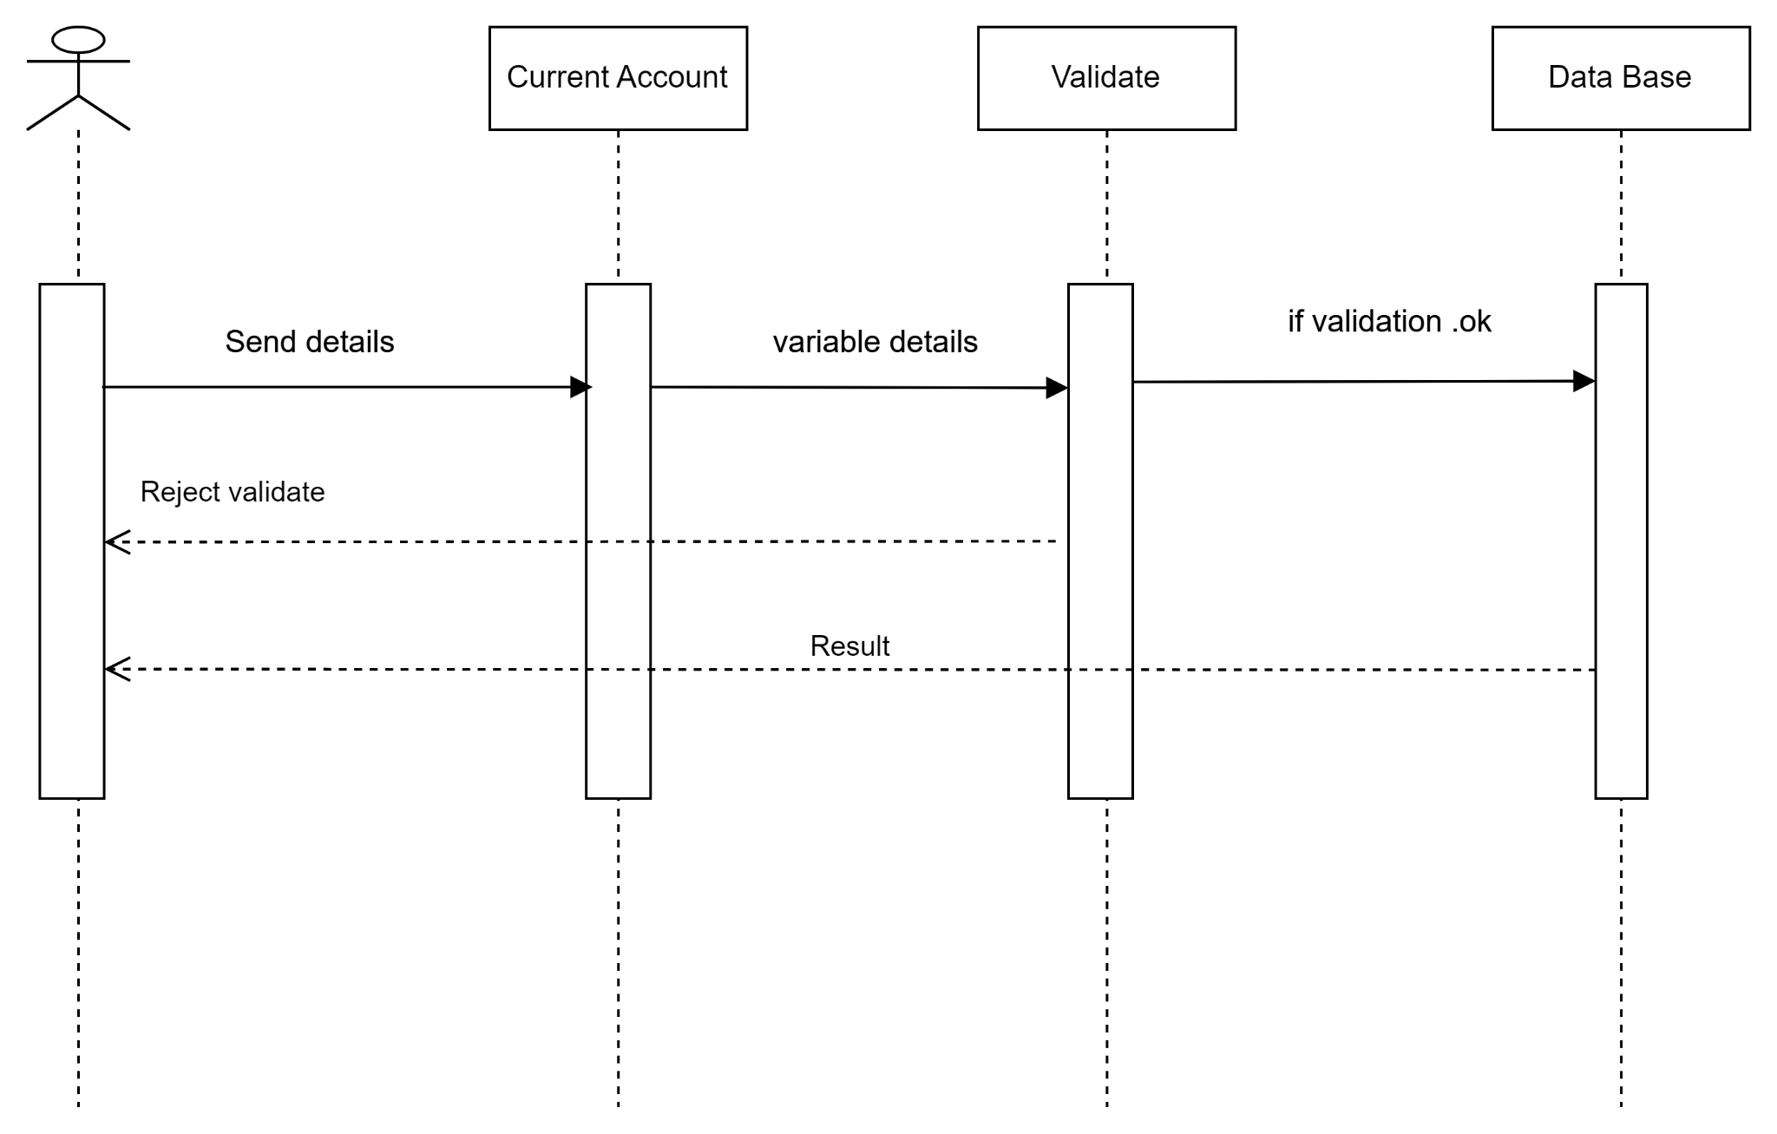

**1.1Check Balance**

1

!1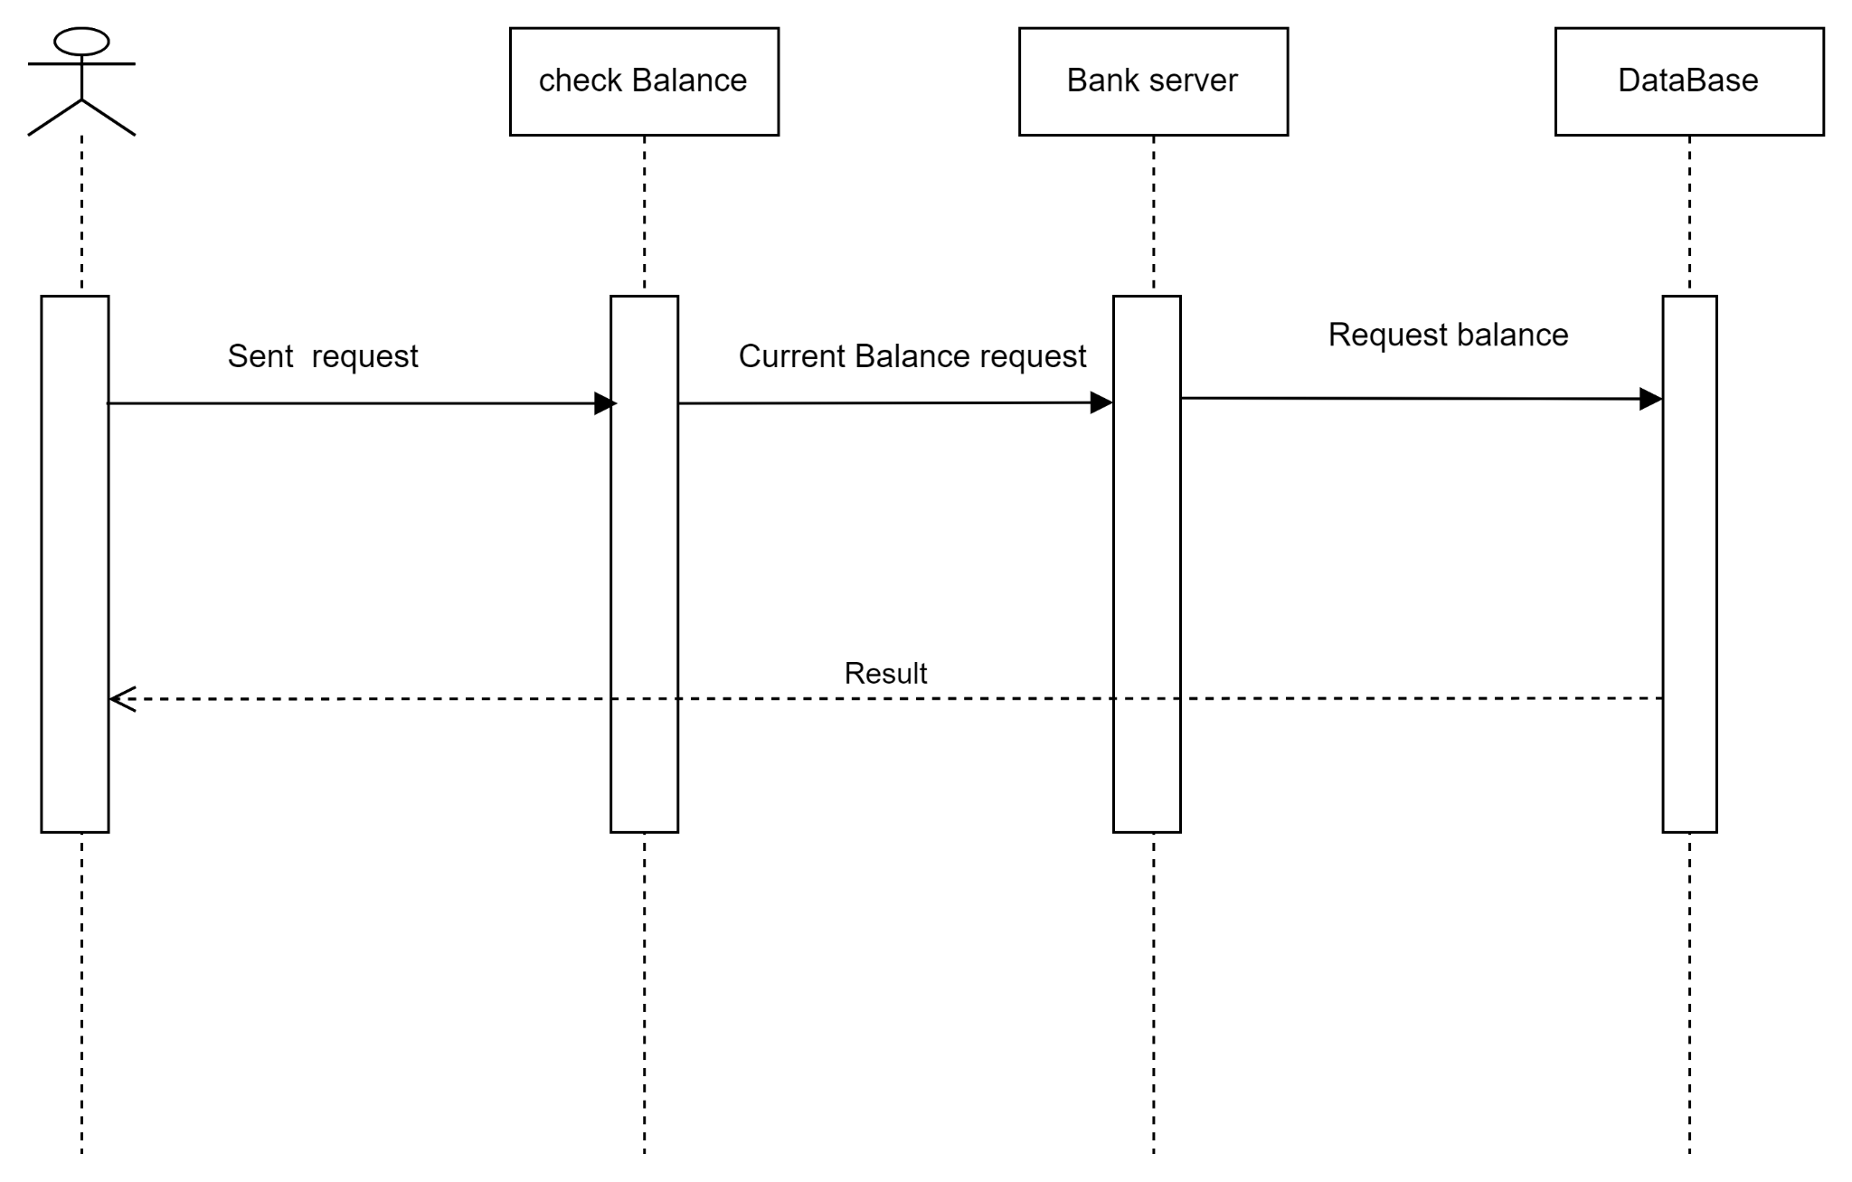

**1.2 Withdraw Money:**

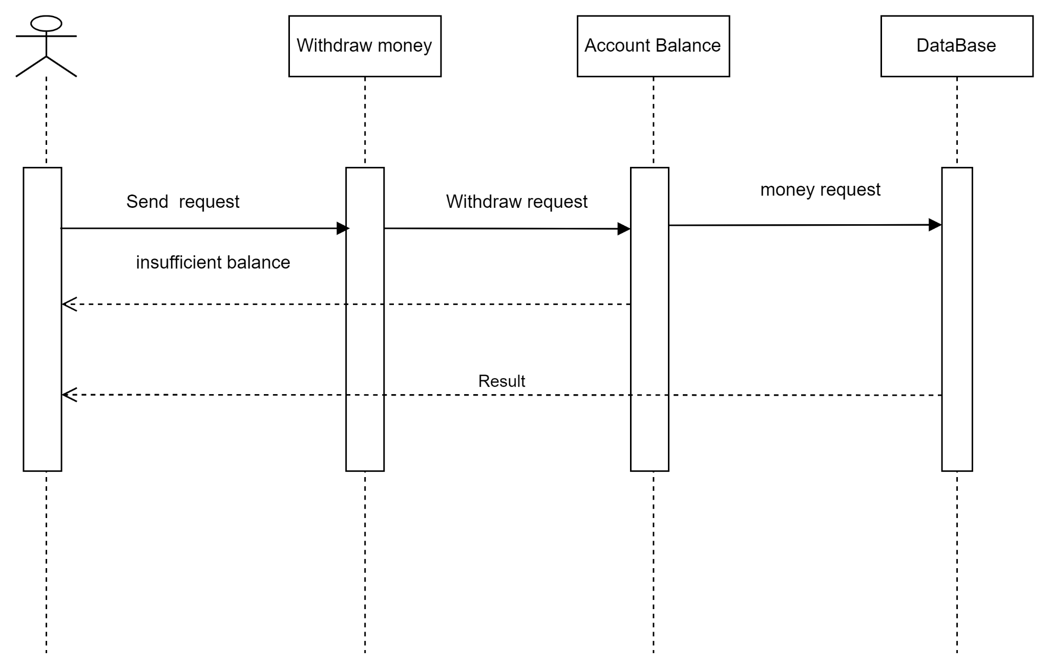

**1.3 Transfer Money**

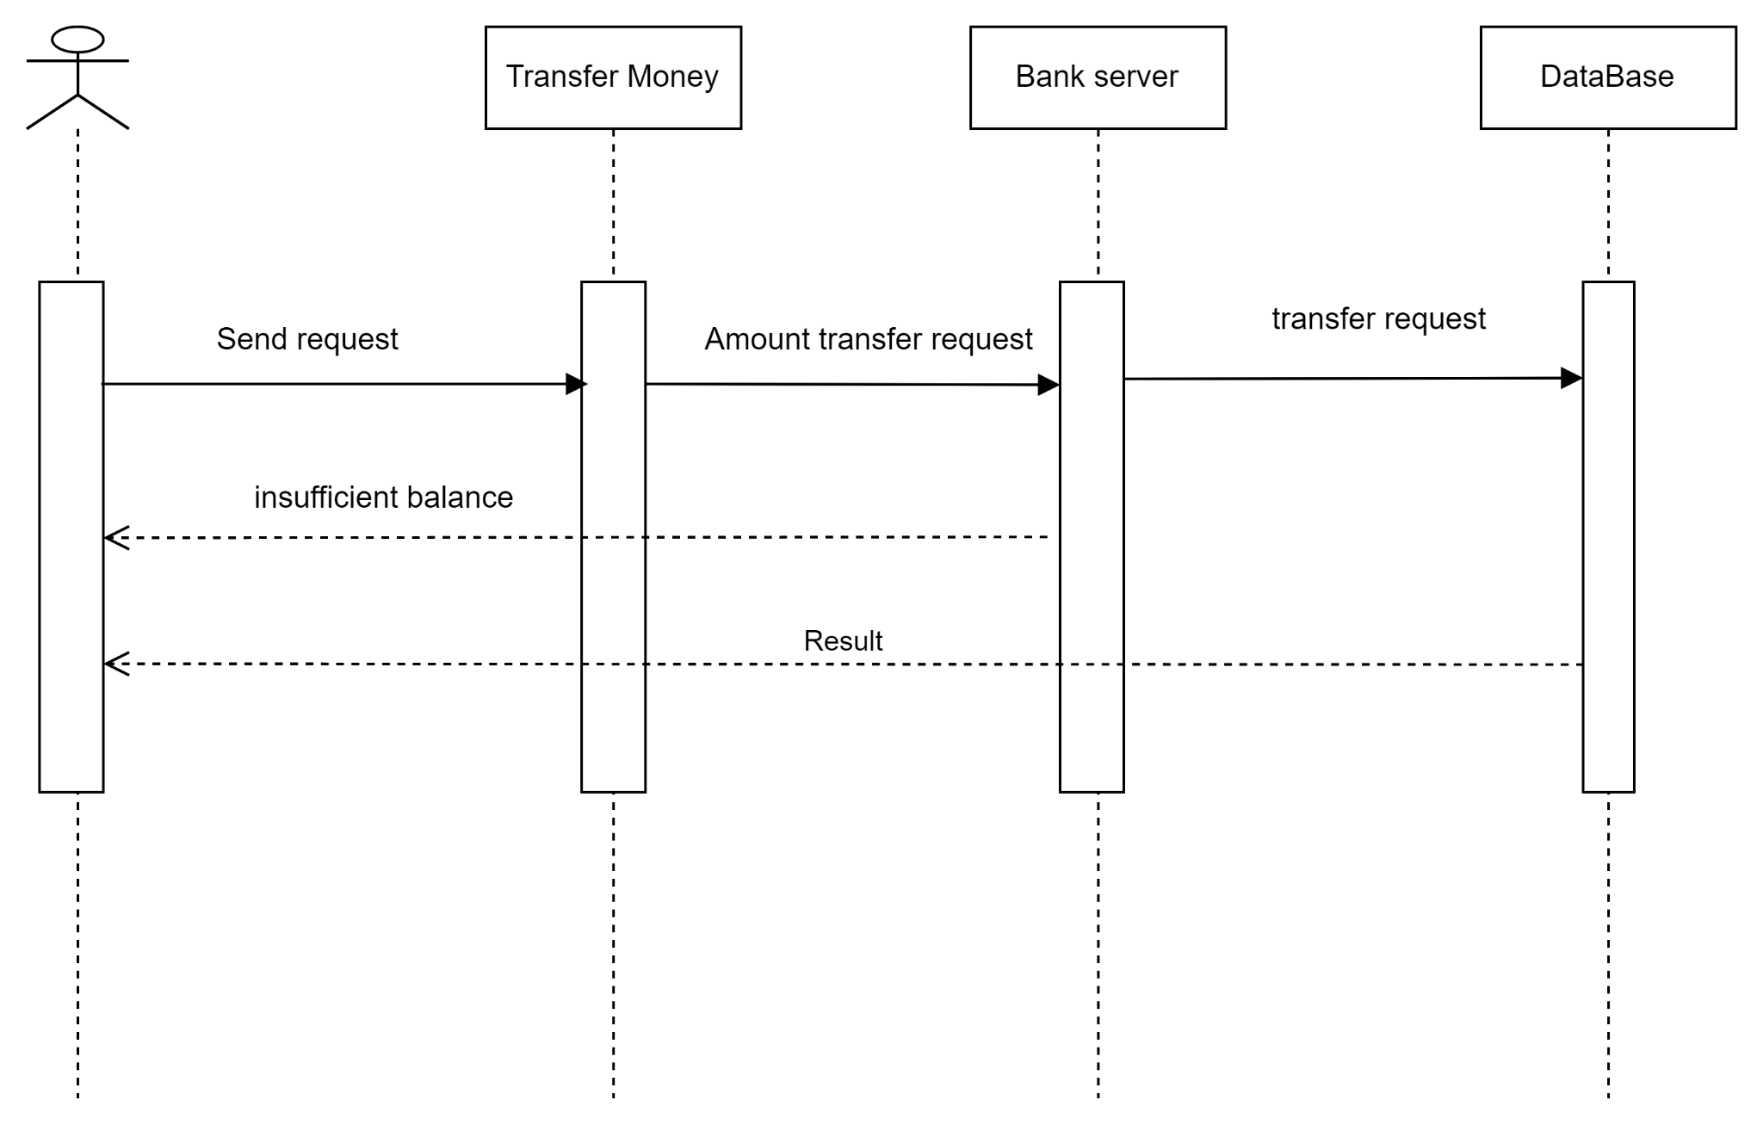

**1.4 Deposit Money:**

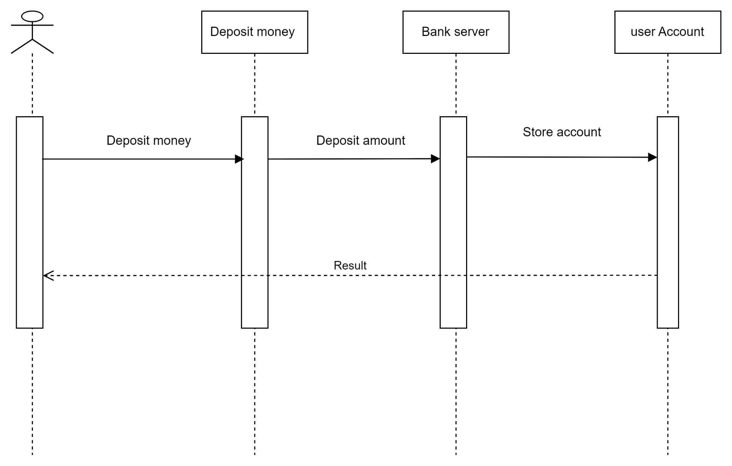

**1.5 Transaction History :**

